EXTRA 10-MINUTE TASK · CASE STUDY
The Tashkent Food-Delivery App
Topic 1 · What is Machine Learning? · works individually or in A/B/C groups

The scenario (read this to students)
A food-delivery startup in Tashkent — call it "Yetkaz" — wants to use machine learning to improve its app. The founders have listed five things they’d like the ML system to do. Your job: for each one, decide which kind of ML problem it is — and be ready to explain why.

The five things Yetkaz wants
For each, answer two questions: (a) Supervised or Unsupervised? (b) If you can, name the exact type — regression, classification, clustering, anomaly detection, or "a recommender."
- Predict the delivery time in minutes for a new order, using distance, time of day, and weather.
- Group customers into segments (no preset categories) so marketing can send each group different offers.
- Automatically flag fake or suspicious reviews that don’t look like normal ones.
- Look at the delivery photo and decide whether it shows the food or not (drivers must upload a real photo).
- Suggest dishes a user will probably order next, based on what similar users ordered.

How to run it (facilitator)
- Post the scenario + the 5 items in chat, or share this on screen.
- Individually (or in A/B/C groups): give 6 minutes to decide all five.
- Then take a show of hands per item and reveal — push for the reasoning, using the test: "Do they have labels? Number or category?"
- Item 5 is the twist — it doesn’t fit the basic boxes; it’s a recommender. A nice bridge to Topic 2.

Answer key (for you)
Sub-task | Answer | Why
1. Predict delivery time (minutes) from distance, time of day, weather | Supervised — Regression | Predicting a NUMBER, and past deliveries have known times (labels).
2. Group customers into segments for targeted offers | Unsupervised — Clustering | No labels — the app discovers natural groups itself.
3. Flag fake / suspicious reviews that don’t look normal | Unsupervised — Anomaly detection | Mostly normal reviews; flag the few odd ones, usually with no labelled fakes.
4. Decide if a delivery photo shows the food or not | Supervised — Classification | Predicting a CATEGORY (food / not-food) from labelled photos.
5. Suggest dishes a user will likely order next | Beyond — Recommender | Suggests items from many users’ behaviour — outside the basic boxes.
Heuristic to leave them with: label present → supervised (number = regression, category = classification); no label → unsupervised (groups = clustering, odd-ones-out = anomaly). Suggesting items across users → recommende

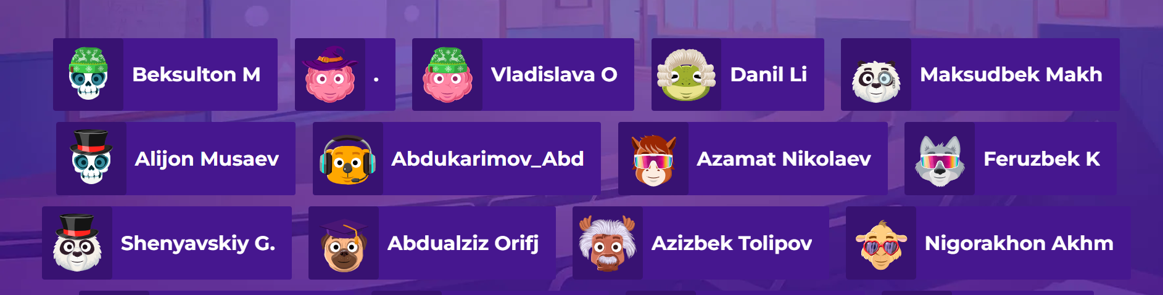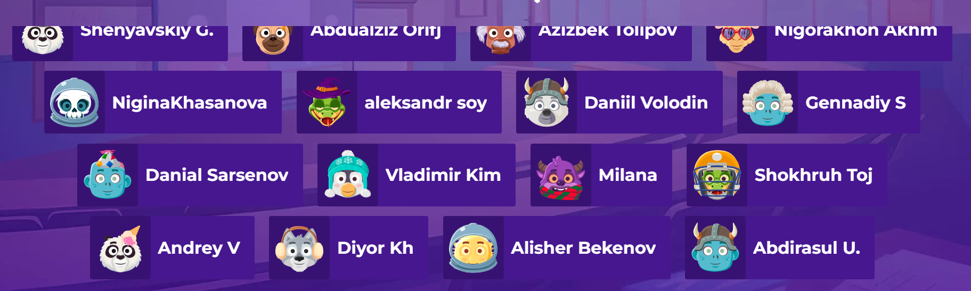r.

